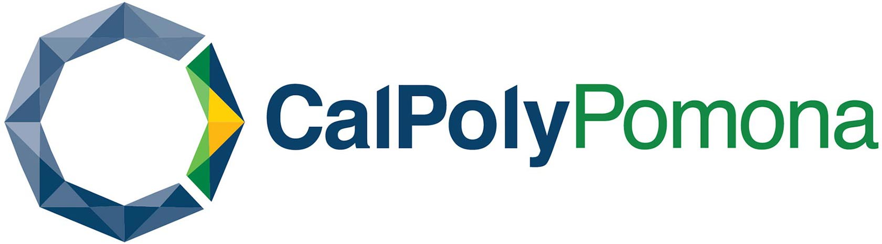

IN-PERSON STUDENT INNOVATION, ENTREPRENEURSHIP
& LEADERSHIP PROGRAM (SIELP) – 14 DAYS
SUMMER 2023

2023年暑期

“國際大學生創新創業領導力課程”
14天

美國加州州立理工大學（波莫那）
2023年7月16日至7月29日
Global Education Institute
Cal Poly Pomona
PROGRAM SCHEDULE 課程安排

Day 1 7/16/2023 周日
 | Arrival at Los Angeles International Airport / Pick-Up from the airport and transportation to Cal Poly Pomona / Check in at campus dorm or university village / Light meal / Grocery shopping before arriving at CPP  學生抵達洛杉磯國際機場/ 校方負責接機、安排車輛送達大學宿舍或者大學公寓，並安排入住/ 提供簡餐 / 途中安排超市購物
Day 2 7/17/2023周一
09:00AM-11:00AM | Campus tour  校園參觀
11:30AM-12:00PM | Welcome luncheon / Exchange with program staff  歡迎午餐 / 與助教和工作人員交流
12:00PM-02:00PM | Welcome ceremony / University introduction / Program orientation  開幕式 / 大學介紹 / 課程內容介紹
02:00PM-04:00PM | Lecture: How to Find Your Business Ideas  課程：尋找屬於你的商業點子
Day 3 7/18/2023周二
09:30AM–11:30AM | Work on business ideas for the final pitch presentation  討論結業演講的商業計劃提案
12:00PM-01:30PM | Brainstorm Lunch: Discussion on business ideas with program staff  午餐會：與助教腦力激盪，討論結業演講的商業計劃提案
01:30PM-03:30PM | Interactive activity: Social mixer  交流活動：破冰遊戲
Day 4 7/19/2023周三
09:00AM-09:00PM | Tour of Hollywood, Santa Monica Beach, and Griffith Observatory  參觀好萊塢，聖塔莫尼卡海灘，以及格里菲斯天文台
Day 5 7/20/2023周四
10:00AM–11:30PM | Cultural Exchange & Team Building with Other International Students  交流活動：與其他國家的國際學生開展文化交流和團隊合作項目
11:30AM-01:00PM | Luncheon & Talent Show  與其他國家的國際學生共進午餐并開展才藝表演
Afternoon | Gym afternoon  大學健身中心活動
Day 6 7/21/2023周五
09:30AM–11:30AM | Hands-on Activity: Blinky Learner Electronics and Circuitry Engineer  實作課程：電子電路工程師
01:30PM-03:30PM | Lecture: Leadership  課程：領導力
Day 7 7/22/2023周六
09:00AM-09:00PM | Tour of San Diego, Mid-Way Museum, and Mexican-style old town  遊覽聖地牙哥、中途號航空母艦博物館、墨西哥風情老城
Day 8 7/23/2023周日
09:00AM- 09:00PM | Shopping at Desert Hills Premium Outlets  沙漠山高級購物中心購物
Day 9 7/24/2023周一
09:30AM–11:30AM | Lecture: Startup Funding  課程：企業的初始資金
01:30PM-03:30PM | Work on final pitch presentation and 1st rehearsal with program staff  與助教進行結業演講的商業計劃提案的第一次排練
Day 10 7/25/2023周二
09:30AM–11:30AM | Hands-on learning experience: Makers Studio  實作課程：大學生創新實驗室
01:30PM-03:30PM | Workshop: Why is Intercultural Communication Skill so important?  交流座談：跨文化溝通技巧的重要性
Day 11 7/26/2023周三
09:30AM–11:30AM | Workshop and Discussion: what can we do to use Chat GPT and AI technology in business  講座與討論：如何利用Chat GPT以及人工智慧技術等方式幫助我們進行商業活動
01:30PM-03:30PM | Work with program staff on final pitch presentation and 2nd rehearsal  與助教完成第二次結業演講排練
Day 12 7/27/2023周四
09:30AM–11:30AM | Final Rehearsal (without program staff)  結業演講排練（自行排練）
01:30PM-04:00PM | Final Pitch  結業演講
05:00PM-06:30PM | Graduation Ceremony & Farewell Dinner  結業式及歡送晚餐
Day 13 7/28/2023周五
08:00AM-08:00PM | Visit Universal Studios Hollywood (tickets not included)  遊覽環球影城（門票自理）
Day 14 7/29/2023周六
 | Checkout, drop-off at LAX and depart for home  退房、送達機場，學生回國
The content of the program schedule above will be subject to change/adjustment with prior notice.
以上內容可能將有所調整或者改變。如發生，我們將提前通知學生。

