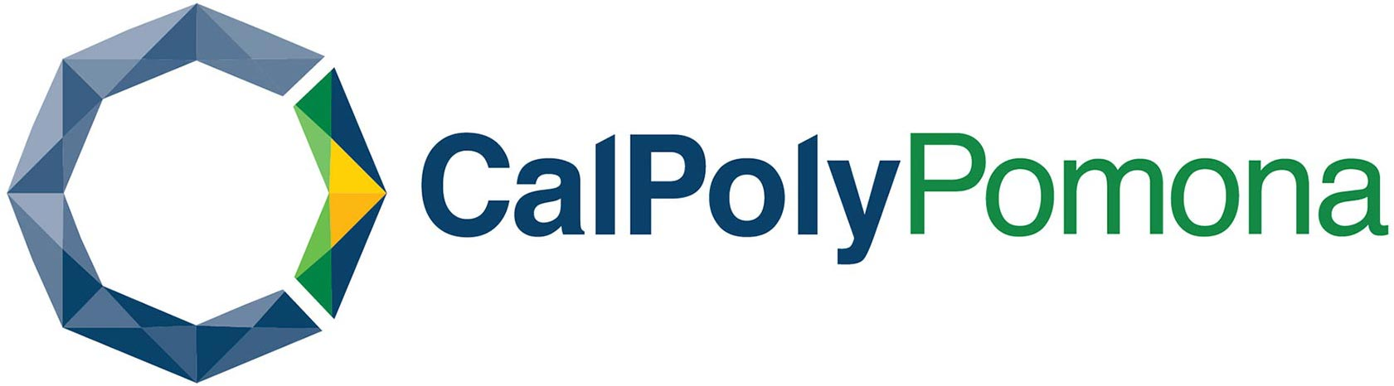

IN-PERSON STUDENT INNOVATION, ENTREPRENEURSHIP
& LEADERSHIP PROGRAM (SIELP) – 20 DAYS
SUMMER 2023

2023年暑期

“國際大學生創新創業領導力項目”
20天

美國加州州立理工大學（波莫那）
2023年7月10日至7月29日
Global Education Institute
Cal Poly Pomona
PROGRAM SCHEDULE 項目排程

Day 1 7/10/2023 週一
 | Arrival at Los Angeles International Airport / Pick-Up from the airport and transportation to Cal Poly Pomona / Check in at campus dorm or university village / Light meal / Grocery shopping before arriving at CPP  學生抵達洛杉磯國際機場 / 校方負責接機、安排車輛送達大學宿舍或者大學公寓，並安排入住 / 提供簡餐 / 途中安排超市購物
Day 2 7/11/2023週二
09:30AM-11:30AM | Campus tour  校園參觀
12:00PM-12:30PM | Welcome luncheon / Exchange with program staff  歡迎午餐 / 並與專案助教和工作人員交流
12:30PM-02:30PM | Welcome ceremony / University introduction / Program orientation  歡迎儀式 / 大學介紹 / 專案須知培訓
02:30PM-03:30PM | Tour and shopping at university farm store  參觀大學農夫市場及購物
Day 3 7/12/2023週三
09:30AM–11:30AM | Lecture: Innovation and Entrepreneurship in the U.S.  課程：美國的創新與創業
01:30PM-03:30PM | Warm-Up Lecture: Improving English Listening and Speaking  熱身課程：提升你的英語聽說能力
Day 4 7/13/2023週四
08:00am-10:00pm | Visit Disneyland (tickets not included)  狄斯奈樂園（門票自理）
Day 5 7/14/2023週五
09:30AM-11:30AM | Interactive Activity led by American Peers  由美國學生及項目助教帶領的互動交流活動
01:30PM-03:30PM | Skill Training Session: Public Speaking and Debate  技能訓練專場：提升公共演講和辯論的能力
Day 6 7/15/2023週六
09:00AM-09:00PM | Tour of Getty Center, California Science Center, and Little Tokyo  參觀蓋蒂中心、加州科學中心，以及小東京
Day 7 7/16/2023周日
09:00AM- 07:00PM | Visit UC Irvine and South Coast Plaza  參觀加州大學爾灣分校以及南海岸購物中心
Day 8 7/17/2023週一
09:30AM–11:30AM | Lecture: Collaborative Leadership and Teamwork  課程：協作領導力及團隊合作
02:00PM-04:00PM | Lecture: How to Find Your Business Ideas  課程：尋找屬於你的商業新點子
Day 9 7/18/2023週二
09:30AM–11:30AM | Work on business ideas for the final pitch presentation  分小組討論並分工開始完成結業演講的商業策劃方案
12:00PM-01:30PM | Brainstorm Lunch: Discussion on business ideas with program staff
 | 午餐會: 與專案助教討論商業策劃方案
01:30PM-03:30PM | Interactive activity: Social mixer  互動交流：破冰活動
Day 10 7/19/2023週三
09:00AM–09:00AM | Tour of Hollywood, Santa Monica Beach, and Griffith Observatory  參觀好萊塢，聖塔莫尼卡海灘，以及格里菲斯天文臺
Day 11 7/20/2023週四
10:00AM–11:30AM | Cultural Exchange & Team Building with Other International Students  交流活動：與其他國家的國際學生開展文化交流和團隊合作專案
11:30AM-01:00PM | Luncheon & Talent Show  與其他國家的國際學生共進午餐並開展才藝表演
Afternoon | Gym afternoon  大學健身中心活動
Day 12 7/21/2023週五
09:30AM–11:30AM | Hands-on Activity: Blinky Learner Electronics and Circuitry Engineer  動手實踐：電子電路工程師
01:30PM-03:30PM | Lecture: Leadership  課程：領導力
Day 13 7/22/2023週六
09:00AM-09:00PM | Tour of San Diego, Mid-Way Museum, and Mexican-style old town  遊覽聖地牙哥、中途號航空母艦博物館、墨西哥風情老城
Day 14 7/23/2023周日
09:00AM-09:00PM | Shopping at Desert Hills Premium Outlets  沙漠奧特萊斯購物
Day 15 7/24/2023週一
09:30AM–11:30AM | Lecture: Startup Funding  課程：初創企業的資金
01:30PM-03:30PM | Work on final pitch presentation and 1st rehearsal with program staff  與項目助教進行結業演講的商業策劃方案的第一次排練
Day 16 7/25/2023週二
09:30AM–11:30AM | Hands-on learning experience: Makers Studio  動手實踐：大學生創新實驗室
01:30PM-03:30PM | Workshop: Why is Intercultural Communication Skill so important?  交流座談：跨文化溝通技巧的重要性
Day 17 7/26/2023週三
09:30AM–11:30AM | Workshop and Discussion: what can we do to use Chat GPT and AI technology in business  講座及討論：如何利用Chat GPT以及人工智慧技術等手段幫助我們實現商業抱負
01:30PM-03:30PM | Work with program staff on final pitch presentation and 2nd rehearsal  與項目助教完成第二次演講排練
Day 18 7/27/2023週四
09:30AM–11:30AM | Final Rehearsal without program staff  結業演講最終排練（自行排練）
01:30PM-04:00PM | Final Pitch  結業演講
05:00PM-06:30PM | Graduation Ceremony & Farewell Dinner  結業儀式及歡送晚餐
Day 19 7/28/2023週五
08:00AM-08:00PM | Visit Universal Studios Hollywood (tickets not included)  遊覽環球影城（門票自理）
Day 20 7/29/2023週六
 | Checkout, drop-off at LAX and depart for home country  退房、送至機場，學生回國
The content of the program schedule above will be subject to change/adjustment with prior notice.
以上內容可能將有所調整或者改變。如發生，我們將提前通知學生。

